_________________________________

Family Group Decision-Making

_________________________________

Impact on Removals

and Permanency in Texas

________________________________

Eugene Wang, Ph.D.

Texas Tech University

August 2010

TABLE OF CONTENTS
TABLE OF CONTENTS 2
EXECUTIVE SUMMARY 3
BACKGROUND 3
Legislation 3
Family Group Decision-Making 3
THE PRESENT EVALUATION 3
RESULTS 3
Removals and Child Safety 3
Descriptive Statistics 3
Structural Equation Model 3
Classification Tree Analysis 3
Accelerated Permanency 3
Descriptive Statistics 3
Structural Equation Modeling/Discrete-Time Survival Analysis 3
Table 4. Time to Placement 3
Classification Tree Analysis 3
SUMMARY AND CONCLUSIONS 3
Removals and Child Safety 3
Permanency 3
TECHNICAL NOTES 3
Removals and Child Safety 3
Structural Equation Model 3
Figure 1. Structural Equation Model 3
Classification Tree Analysis 3
Table 5. Classification Table of the Removals Classification Tree Analysis 3
Figure 2. Gains Chart - Removals 3
Latent Class Analysis 3
Table 6. Summary of the Latent Class Analysis 3
Permanency 3
Structural Equation Model/Discrete-Time Survival Analysis 3
Figure 3. Structural Equation Model/Discrete-Time Survival Analysis 3
Figure 4. Survival Curves for Family Team Meetings and Family Group Conferences 3
Classification Tree Analysis 3
Table 7. Classification Table of the Classification Tree Analysis 3
Figure 5. Gains Chart for Reunification with Family 3
GLOSSARY 3

APPENDICES
- Table 1. Descriptive data – removals
- Table 2. Descriptive data – recurrence
- Table 3. Descriptive data – substitute care
- Classification tree for removals
- Classification tree for multiple investigations with the CART algorithm
- Classification tree for multiple investigations with the CHAID algorithm
- Classification tree for multiple confirmed with the CART algorithm
- Classification tree for multiple confirmed with the CHAID algorithm
- Mplus output for removal structural equation model
- Mplus output for 4 tested recurrence structural equation models
- Mplus output for removal latent class analysis
- Graphs for all investigation variables
- Cross tabulation tables for all pairs of categorical investigation variables
- Correlations for all pairs of continuous investigation variables
- Odds ratios for removal
- Odds ratios for multiple investigations
- Odds ratios for multiple confirmed
- Classification tree for permanency
- Mplus output for permanency structural equation model/discrete-time survival analysis
- Mplus output for latent class analysis of permanency
- Descriptive statistics for all permanency variables
- Boxplots for all permanency variables
- Cross tabulation tables for all pairs of permanency variables
- Odds ratios for reunification
- Odds ratios for placement with relatives
- Odds ratios for adoption

EXECUTIVE SUMMARY
In 2009, the 81st Texas Legislature passed Senate Bill (SB) 1, Rider 34, requiring the Department of Family and Protective Services (DFPS) to hire an outside evaluator to determine the effectiveness of the Child Protective Services (CPS) Family Group Decision-Making (FGDM) program. DFPS contracted with Texas Tech University to conduct the evaluation for the period September 1, 2003, through March 31, 2009. This report focuses on two models of FGDM service planning, Family Team Meetings and Family Group Conferences, and their impact on removals, child safety through recurrence of investigations, and accelerating children's exits from the foster care system through family reunification, permanent placement with relatives, or adoption.
A Family Group Conference is a process where families join with relatives and friends to develop a plan that ensures children are cared for and protected from future harm. The “family group” is vested with a high degree of decision-making authority and responsibility. It is typically conducted in the Conservatorship stage of service following the placement of a child into care, but can also be held in Family Based Safety Services. A Family Team Meeting is designed as a pre-removal quick response to child safety concerns, and is used to achieve positive outcomes for children in the earliest stages of DFPS and family connection. It is a process of engaging family, community members, and other caregivers in critical decisions related to child protection, safety, placement and permanence. Family Team Meetings are primarily held in investigations but can also be held in Family Based Safety Services and Conservatorship cases.

The report is divided into two sections; the first section is dedicated to discussing removals and recurrence in investigations and Family Based Safety Services while the second section addresses exiting the foster care system. The purpose of the first section is to report on the goal of “preventing removals while keeping children safe.” For the purposes of this evaluation, safety was defined as (a) non-recurrence of any type of completed investigation, or (b) non-recurrence of confirmed investigations. Removal is defined as a child being removed from the home at the investigation stage or a child being removed from home after the investigation stage has been closed and the family's case has been opened for Family Based Safety Services.
The results of the data analyses indicate that Family Team Meetings and Family Group Conferences decrease the odds of removals. After adjusting for other variables, Family Team Meetings during the investigation stage of service reduced the odds of removal by 8 percent. Additionally during the Family Based Safety Services stage of service, Family Team Meetings reduced the odds of removal by 15 percent and Family Group Conferences reduced the odds of removal by 8 percent. The effectiveness of Family Team Meetings during the investigation stage of service was more pronounced for high-risk cases than for low risk cases. This is likely because the risk of removal for cases with low risk scores is already very low, and cannot be significantly lowered, while meetings with families can moderate the risk for removal for cases with high risk scores.
Evidence was inconsistent of the impact of Family Team Meetings and Family Group Conferences on recurrences of investigations. For example, the results of vastly different models were achieved using two slightly different algorithms in the classification tree analysis. None of four recurrence structural equation models that were tested had an adequate fit to the data. Therefore, no conclusions could be reached as to the impact of Family Team Meetings and Family Group Conferences on recurrences of investigations.
The results also indicate that Family Team Meetings increase the speed with which children attain permanent placement (were reunified with their family or were permanently placed with a relative). At the end of 12 months after removal, less than 40 percent of all children were in their permanent placement. However, 62 percent of children who had a Family Team Meeting during the investigation stage of service were in permanent placements at the end of the twelfth month. Family Group Conferences held after removal did not affect time to permanent placement.
In addition to speed to exit from foster care, the results also indicated that Family Team Meetings and Family Group Conferences increase the odds of achieving the desired outcome of placement with family. Family Team Meetings and Family Group Conferences increased the odds of reunification with family by 48 percent and the odds of permanent placement with relatives by 22 percent. Overall, Family Group Decision Making meetings (whether they are Family Team Meetings or Family Group Conferences) have a significant positive impact on the desired outcomes of reducing the odds of removal and of faster reunification with family or permanent placement with relatives. Their impact on recurrence of an investigation is not clear.

BACKGROUND

Legislation
In 2009, the 81st Texas Legislature passed Senate Bill (SB) 1, Rider 34, requiring DFPS to hire an outside evaluator to determine the effectiveness of the CPS Family Group Decision-Making program. DFPS contracted with Texas Tech University to conduct the evaluation for the period September 1, 2004, through March 31, 2009. The evaluator received data to extend the evaluation period to cover September 1, 2003, through March 31, 2009. DFPS accepted the extended evaluation period.

Family Group Decision-Making
Family Group Decision-Making is a practice approach to working with families involved with the child welfare system. The term “family” is interpreted broadly to include extended family members, friends, neighbors, and others identified by the family as potential sources of support. Family Group Decision-Making itself is an umbrella term used to characterize several practice models that share a common philosophy. It is characterized as a practice which is family-centered, family strengths-oriented, culturally relevant, and community-based while remaining focused on safety and the best interest of the child. It recognizes that families are most knowledgeable about themselves and can make well-informed decisions, and that individuals can find security and a sense of belonging within their families.
Though there are a number of variations on Family Group Decision Making, three basic practice models are currently in use in Texas: Family Group Conferences, Family Team Meetings and Circles of Support.
- A Family Group Conference is a process where families join with relatives and friends to develop a plan that ensures children are cared for and protected from future harm. The “family group” is vested with a high degree of decision-making authority and responsibility. It is typically conducted in the Conservatorship stage of service following the placement of a child into care but can also now be held in Family Based Safety Services.
- .A Family Team Meeting is designed as a pre-removal quick response to child safety concerns, and is used to achieve positive outcomes for children in the earliest stages of DFPS and family connection during the investigation stage of service. It is a process of engaging family, community members, and other caregivers in critical decisions related to child protection, safety, placement and permanence. Family Team Meetings are primarily held in investigations but can also be held in Family Based Safety Services and Conservatorship cases.
- A Circle of Support is a youth-focused/driven meeting with the primary purpose of developing a transition plan for older youth from foster care to adulthood. It includes broad participation of the youth’s support network. It is required for youth 16 years and older but may begin as early as 14 years of age. There was not enough data to evaluate Circles of Support in the present study.

THE PRESENT EVALUATION
The present evaluation was designed to assess the impact of Family Group Decision-Making on two goals. The first goal was “preventing removals while keeping children safe.” For the purposes of the current evaluation, safety was defined as (a) non-recurrence of any type of completed investigation, or (b) non-recurrence of confirmed investigations. The second goal was expediting children's exits from foster care through family reunification, or permanent placement with relatives (see footnote 1 regarding adoption). These two goals were evaluated separately and reported throughout this report under the headings of “Removals and Child Safety” and “Accelerated Permanency.”
Further, for Removals and Child Safety, removals were analyzed separately from recurrence. Removals were analyzed as the outcome of each individual investigation of a family. Thus, a family could have one or more investigations. To study recurrence, cases were matched and then categorized as (a) a single investigation (i.e., no recurrence), (b) multiple completed investigations without any confirmed investigation, (c) multiple completed investigations with only 1 confirmed investigation, and (d) multiple completed investigations with 2 or more confirmed.
Many different types of analyses were conducted, including descriptive (univariate), bivariate (correlations, cross tabulations), and exploratory and confirmatory inferential statistics. There were three major types of inferential analyses conducted: latent class analyses (used to explore whether there were identifiable smaller groups of individuals), classification tree analyses (used to identify which predictors are most related to type of permanent placement), and structural equation modeling (used to analyze impacts of Family Team Meetings and Family Group Conferences on removal, accounting for the effects of other variables).
The structural equation model/discrete-time survival analysis answers the question: What are the effects of Family Team Meetings and Family Group Conferences, with everything else being equal (i.e., adjusting or controlling for other variables)?
The classification tree analysis answers the question: Under what conditions are Family Team Meetings and Family Group Conferences most effective?
The latent class analysis answers the question: Are there smaller groups (“classes”) of individuals that have not yet been identified? However, the results of the latent class analysis for removals did not add any information; therefore, the results from the removal latent class analysis are reported only in Appendix 8.
Latent class analysis and classification tree analysis are exploratory techniques and results from them should be treated more cautiously than those from the structural equation model, which is a confirmatory technique. Because the structural equation model analysis can be viewed as the most accurate way to represent the results, odds ratios that are reported are those from this type of analysis. Odds ratios from bivariate (i.e., cross tabulation) analyses are reported in appendices.

RESULTS

Removals and Child Safety
The focus of this section is on the impacts of Family Team Meetings and Family Group Conferences on removals and recurrence. The purpose of this section is to report on the goal of “preventing removals while keeping children safe.” For the purposes of the section, safety was defined as (a) non-recurrence of any type of completed investigation, or (b) non-recurrence of confirmed investigations.
The results of the structural equation model analysis indicate that Family Team Meetings and Family Group Conferences decrease the odds of removals. After adjusting for other variables, Family Team Meetings during the investigation stage of service reduced the odds of removal by 8 percent. Additionally during the Family Based Safety Services stage, Family Team Meetings reduced the odds of removal by 15 percent and Family Group Conferences reduced the odds of removal by 8 percent. The effectiveness of Family Team Meetings during the investigation stage of service was more pronounced for cases with high total risk scores than for cases with low total risk scores. This is likely because the risk of removal for cases with low risk scores is already very low, and cannot be significantly lowered, while meetings with families can moderate the risk for removal for cases with high risk scores.
The evidence was inconsistent (and often contradictory) regarding the impact of Family Team Meetings and Family Group Conferences on recurrence of investigations. Therefore, no conclusions could be reached as to their impact on recurrence. Results from analyses of recurrence are reported in the appendices.

Descriptive Statistics
The removal analyses were conducted on 874,177 investigation, Family Based Services and Conservatorship cases between September 1, 2003 and March 31, 2009. Table 1 (see Appendix 1) includes descriptive information on these cases.
Some things that stand out from the removal descriptive data are (1) over 2/3 of the families had an annual income less than $20,150; (2) over half of the cases had missing data on the marital status variable; (3) there were a very small proportion who were served in Family Team Meetings or Family Group Conference, particularly during Family Based Safety Services; (4) about 25 percent of the investigations were confirmed; and (5) children were removed in about 5 percent of investigations.

Structural Equation Model
The structural equation model looked at the effects on removal of Family Team Meetings during the investigation stage of service and Family Based Safety Services and Family Group Conferences during Family Based Safety Services, adjusting (or “controlling”) for other variables (i.e., “everything else being equal”). These variables included age, race, annual family income, marital status, being a teen parent, the risk score from the Texas Concept Guided Risk & Safety Assessment, and Strengthening Families Initiative payments during Family Based Safety Services and in Family Reunification.
Family Team Meetings and Family Group Conferences were treated as “mediating” variables: they were treated as events that are modifiable and under the control of the agency. The other variables (labeled “background” variables in Figure 1 were treated as demographic variables (i.e., age, race, annual family income, etc.). These variables were treated, by and large, as characteristics brought to the situation by the child and/or caregiver(s).
Family Team Meetings and Family Group Conferences reduced the odds of removal adjusting for other variables, but less so than when the other variables were not considered. Family Team Meetings during the investigation stage of service reduced the odds of removal by 8 percent, Family Team Meetings during Family Based Safety Services reduced the odds of removal by 15 percent, and Family Group Conferences during Family Based Safety Services reduced the odds of removal by 8 percent.

Classification Tree Analysis
Classification tree analysis was used to determine the impact of Family Team Meetings and Family Group Conferences on whether or not removal occurred during that investigation. This type of analysis was done because it answers a different kind of question (“What variables mediate or moderate the effect(s)?”) than does a structural equation model (“What is the effect after adjusting for other variables?”).
The potential predictors for the classification tree analysis included:
- Race
- Age
- Family income
- Total risk score from the Texas Concept Guided Risk & Safety Assessment
- Marital status
- Teen parent
- Abuse type
- Strengthening Families Initiative payments in Family Based Safety Services
- Family Team Meeting during Investigation
- Family Team Meeting during Family Based Safety Services
- Family Group Conference during Family Based Safety Services
Results (see the model in Appendix 1) from the classification tree model indicated that the risk score from the Texas Concept Guided Risk & Safety Assessment was the best predictor of removal. With one exception, the probability of removal increased with increases in risk scores. Family Team Meetings during the investigation stage of service reduced the likelihood of removal when there was high risk; however, for families with lower risk, Family Team Meetings during the investigation stage of service increased the likelihood of removal. This may be explained by risks being identified during a Family Team Meeting that were not evident during the risk assessment.
Several variables were not significant predictors of removal (when these others were considered): race, family income, marital status, teen parent, Strengthening Families Initiative payments in Family Based Safety Services, and a Family Team Meeting or Family Group Conference during Family Based Safety Services.
Table 2 (see Appendix 2) provides descriptive data for the recurrence sample. To study recurrence, cases were matched and then categorized as (a) a single investigation (i.e., no recurrence), (b) multiple completed investigations without any confirmed, (c) multiple completed investigations with only 1 confirmed, and (d) multiple completed investigations with 2 or more confirmed.

Accelerated Permanency
The focus of this section is on the impact of Family Team Meetings and Family Group Conferences on accelerating children's exits from the foster care system through family reunification, permanent placement with relatives, or adoption.
The results of the structural equation model/discrete-time survival analysis indicate that Family Team Meetings increased the speed with which children attain permanent placement. At the end of 12 months after removal, less than 40 percent of all children had permanent placement. However, 62 percent of children who had a Family Team Meeting during the investigation stage of service were in permanent placements at the end of the twelfth month. Family Group Conferences held after removal did not affect time to permanent placement.
In addition to speed to exit from foster care, the data also indicated that Family Team Meetings and Family Group Conferences increase the odds of achieving the desired outcome of placement with family. Family Team Meetings and Family Group Conferences increased the odds of reunification with family by 48 percent and the odds of permanent placement with relatives by 22 percent.

Descriptive Statistics
The analyses were conducted on 80,693 children removed (i.e., in foster care) between September 1, 2003 and March 31, 2009. Table 3 (see Appendix 3) includes descriptive information on these children:
Some things that stand out from the descriptive data are (1) over half the families had an annual income less than $10,150; (2) 41 percent of the cases had unusable data on the marital status variable; (3) there were a very small proportion of families who participated in the Strengthening Families Initiative, and a very small proportion who had Family Team Meetings during Family Based Safety Services or after Removal or who had a Family Group Conference during Family Based Safety Services; (4) about 25 percent of the sample was still in care; and (5) the median number of months in care for those still in care was approximately 5 months longer than the median number of months in care for those children who had been placed.
These differences in the proportion of cases which had and did not have Family Team Meetings or Family Group Conferences pose serious methodological problems. For example, because of the extremely low proportions receiving a meeting or conference during Family Based Safety Services, those results are potentially very suspect, and are only reported in the appendices. Further, marital status was dropped as a variable in the inferential analyses because of the proportion of missing data.

Structural Equation Modeling/Discrete-Time Survival Analysis
This analysis was a combination of a structural equation model and a discrete-time survival analysis. The basic analysis looked at the effects of Family Team Meetings (in the investigation stage of service, Family Based Safety Services, and after Removal) and Family Group Conferences (in Family Based Safety Services and after Removal) on type of permanent placement (reunification with family, placement with relatives, and adoption) and speed to permanent placement, controlling for other variables (i.e., “everything else being equal”). These variables included age, gender, race, annual family income, marital status, being a teen parent, the risk score from the Texas Concept Guided Risk & Safety Assessment, and Strengthening Families Initiative payments during Family Based Safety Services and in Family Reunification.
Family Team Meetings and Family Group Conferences were treated as “mediating” variables -- events that are modifiable and under the control of the agency. The other variables (labeled “background” variables in Figure 3, p. 30) were treated as demographic variables (i.e., age, gender, race, annual family income, etc.). These variables were treated, by and large, as characteristics brought to the situation by the child and/or caregiver(s).
As for type of permanent placement, Family Group Conferences after Removal increased the odds of reunification with family by 30 percent and the odds of placement with relatives by 8 percent, compared to adoption - everything else being equal (i.e., adjusted for covariate effects).
Results for speed to permanent placement are found in Table 4. This table represents the percentage of children who were placed at the end of each 3-month period after removal. Of the overall sample, less than 40 percent had been placed at the end of 12 months, and less than two-thirds at the end of 18 months. However, over 62 percent of those who had Family Team Meetings during the investigation stage of service had been placed at the end of 12 months, and 85 percent at the end of 18 months.

Table 4. Time to Placement
 | 3  months | 6  months | 9  months | 12  months | 15  months | 18  months
Overall (everyone) | 6.4% | 11.8% | 20.6% | 39.4% | 50.6% | 63.1%
Family Team Meetings – Investigation | 12.7% | 22.6% | 37.4% | 62.2% | 74.5% | 85.1%
Family Team Meetings – after Removal | 7.4% | 13.4% | 23.2% | 43.5% | 55.2% | 67.8%
Family Group Conferences – after Removal | 6.4% | 11.7% | 20.5% | 39.2% | 50.4% | 62.9%
As for speed to type of permanent placement, results indicated that reunification with family happens faster than placement with relatives, which happens faster than adoption.

Classification Tree Analysis
Classification tree analysis was used to determine the impact of Family Team Meetings and Family Group Conferences on type of permanent placement. The potential predictors included:
- Gender
- Race
- Age
- Family income
- Total risk score from the Texas Concept Guided Risk & Safety Assessment
- Marital status
- Teen parent
- Removal reason
- Strengthening Families Initiative payments in Family Reunification
- Strengthening Families Initiative payments in Family Based Safety Services
- Family Team Meeting during Investigation
- Family Team Meeting during Family Based Safety Services
- Family Team Meeting after Removal
- Family Group Conference during Family Based Safety Services
- Family Group Conference after Removal
Results from the classification tree model (see Appendix 15) indicated that child age was the best predictor of type of permanent placement, and annual family income was the second best predictor. Family Group Conferences after Removal increased reunification with family and placement with relatives relative to adoption, particularly for children under the age of 9. The other variables that significantly predicted differential permanent placement were: race, marital status, teen parent, stage at entry, and removal reason. Thus, gender, risk score, Strengthening Families Initiative (SFI) payments, Family Team Meetings, and Family Group Conferences during Family Based Safety Services were not significant predictors in this model.

SUMMARY AND CONCLUSIONS

Removals and Child Safety
For removals, the impact of meetings and conferences on reducing the odds of removal was positive: reducing the odds of removal by 8 percent for Family Team Meetings during the investigation stage of service and Family Group Conferences during Family Based Safety Services, and by 15 percent for Family Team Meetings during Family Based Safety Services. Classification tree analyses found the impact was stronger for Family Team Meetings during the investigation stage of service, and more for cases with high risk than for cases with low risk. Risk level, abuse type, and age of the oldest victim were the best predictors of removal, but Family Team Meetings during investigation was the fourth best predictor of removal in the classification tree analysis.
Thus, everything else being equal, Family Team Meetings and Family Group Conferences have a small, but significant, impact on reducing the odds of removals. When examining specific conditions in which Family Team Meetings are most effective, the impacts increase as the risk increases.
Conclusions for the impact of Family Team Meetings and Family Group Conferences are much more vague for recurrence than for removals because the evidence for their impact is much less consistent (and more conflicting) for recurrence than for removals. Assessing risk of recurrence was difficult because (a) there are multiple ways to define recurrence (two or more investigations, two or more confirmed investigations, two or more within a specific time frame, etc.), and (b) there was a very low proportion of recurrent cases, particularly those cases which have either a Family Team Meeting or a Family Group Conference.

Permanency
Overall, results suggest that Family Group Conferences after Removal increased the odds of reunification with family by 30 percent and placement with relatives by 8 percent. However, Family Group Conferences after Removal did not have any impact on speed to permanent placement.
Family Team Meetings generally increased the odds of reunification with family and placement with relatives compared to adoption, and increased speed to permanent placement (relative to the population). These effects were the most dramatic for Family Team Meetings during the investigation stage of service: they increased the odds of reunification by 33 percent while reducing the odds of adoption by 85 percent and dramatically increasing the percentage of children in permanent placement at the end of 12 or 18 months (by approximately 22 percent over the average).
Of particular note is the consistency of these general findings across all types and levels of analyses, thus strengthening the conclusions. For example, the odds ratios did not decrease much from the simple cross tabulated odds ratios when adding other variables into an inferential model. Adding variables will usually dilute the power of an individual variable; the fact that adding variables did not dilute the power very much is very encouraging as to the positive impact of Family Team Meetings and Family Group Conferences on permanency.

TECHNICAL NOTES

Removals and Child Safety
None of the results of the inferential statistics were stable when examining recurrence. For example, two different classification tree algorithms (CART and CHAID) produced vastly different results. When conducting the structural equation models for recurrence, many of the models would not converge (i.e., produced error messages and would not produce any results). Those that did converge produced results with poor model fit.
The most likely explanation for these problems is the very low proportion of cases with a Family Team Meeting or a Family Group Conference, making these types of analyses almost impossible. Further, it affected the classification tree analysis, which is typically unaffected by vastly disparate proportions.
Thus, results from the inferential analyses of recurrence are not used to reach conclusions. However, these results are provided in Appendix 7.

Structural Equation Model
Variables used in the structural equation model:
- Age
- Teen Parent (Y/N)
- Race (coded into White, Black, Hispanic)
- Family Income
- Total risk score from the Texas Concept Guided Risk & Safety Assessment
- Strengthening Families Initiative payments during Family Based Safety Services (SFI FPR)
- Family Team Meeting during the investigation stage of service (FTM INV)
- Family Team Meeting during Family Based Safety Services (FTM FPR)
- Family Group Conference during Family Based Safety Services (FGC FPR)
- Removed (Y/N)
* Note. The analysis was conducted without marital status in order to obtain accurate odds ratios.

Figure 1. Structural Equation Model
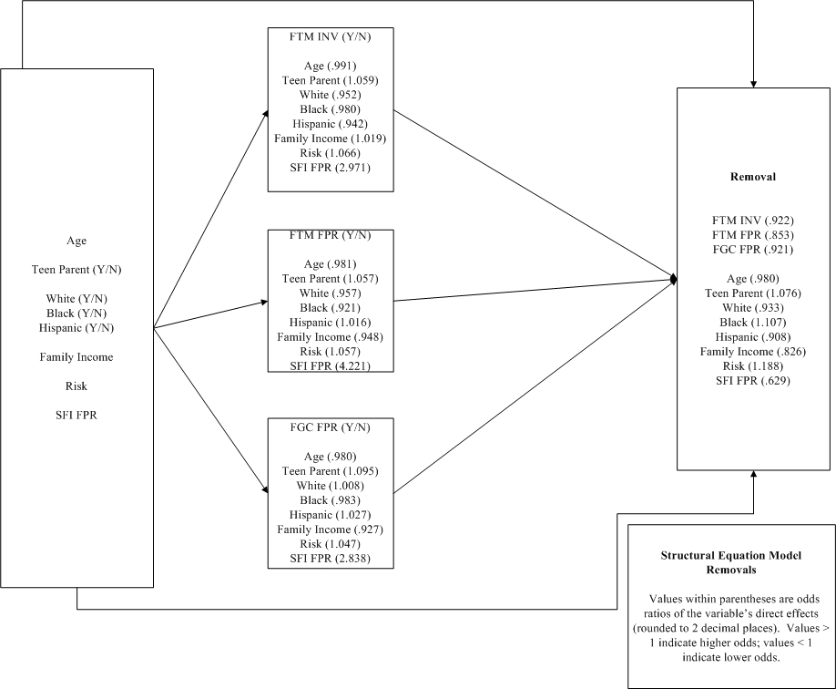

- Note: SFI FPR = Strengthening Families Initiative during Family Based Safety Services; FTM INV = Family Team Meeting during the investigation stage of service; FTM FPR = Family Team Meeting during Family Based Safety Services; FGC FPR = Family Group Conference during Family Based Safety Services
- Note: In a structural equation model, odds ratios are computed by taking the natural logarithm of the parameter value
For visual simplicity, the structural equation model (Figure 1) does not represent all the paths that were tested. Thus, removal is regressed on the 3 mediators and the 8 background variables (or a total of 24 paths); and each of the 3 mediators is regressed on each of the 8 background variables (or 24 paths). The values represented in the structural equation model are the odds ratios of the direct effects (i.e., no indirect effects were estimated).

Classification Tree Analysis
Because classification tree analysis is an exploratory technique, results are particularly sensitive to which variables (both predictor and outcome) are chosen. The classification tree model is available in Appendix 1. Interpretation starts at Node 0 (5.1 percent removed), with risk score being the best predictor of differences in likelihood of removal: there were no removals for the lowest risk cases (those with scores of 6 or less), while 21 percent were removed when the cases had risk scores greater than 21. Each “branch” of the tree continues to split (using the best predictor at that node) until no statistical improvement (based on differences in chi square values or a small sample size criterion) can be obtained by splitting.

Table 5. Classification Table of the Removals Classification Tree Analysis
Observed | Predicted
Observed | Not Removed | Removed | Percent Correct
Not Removed | 822,372 | 7,617 | 99.1%
Removed | 34,437 | 9,751 | 22.1%
Overall Percentage | 98.0% | 2.0% | 95.2%
Growing Method: CHAID
Dependent Variable: Removed during this investigation

Although the percentage of removed correctly predicted by the model (22.1 percent) seems low, it is a significant improvement over chance (Relative Improvement Over Chance of 11.44). This improvement over chance prediction is represented in gains chart for removal (Figure 2). The diagonal line represents chance prediction, and the area under the curve (i.e., between the curve and the diagonal line) represents improvement over chance prediction.

Figure 2. Gains Chart - Removals
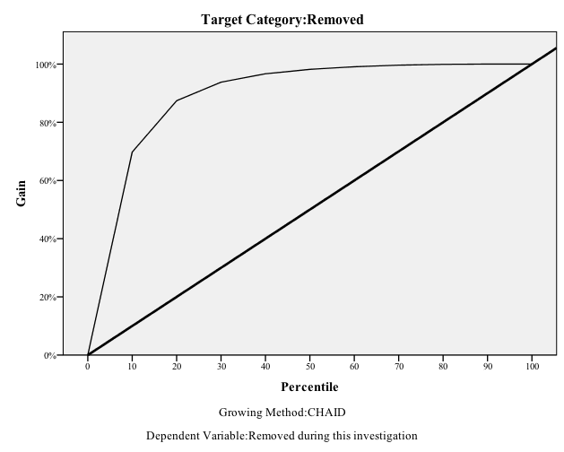

Latent Class Analysis
Latent classes are unobservable (latent) subgroups or segments. Cases within the same latent class are homogenous on certain criteria, while cases in different latent classes are dissimilar from each other in certain important ways.
In the analysis of the removal data, the following variables were used:
- Age
- Race
- Marital status (married/not)
- Teen parent
- Family income
- Total risk score from the Texas Concept Guided Risk & Safety Assessment
A 4-class model was the best fit to the data (see Appendix 8). We named Class 1 the “Unmarried” class, Class 2 the “Young Child” class, Class 3 the “Married” class, and Class 4 the “Teen Parent” class. See Table 6 for a summary of the classes and the percent of the sample that fit into each class.

Table 6. Summary of the Latent Class Analysis
 | Class 1  (42%) | Class 2  (9%) | Class 3  (4%) | Class 4  (46%)
Race
White | 34.7% | 31.9% | 38.8% | 26.3%
Black | 24.2 | 24.0 | 14.5 | 23.2
Hispanic | 37.5 | 31.3 | 40.8 | 49.2
Native American | 0.1 | 0.1 | 0.2 | 0.1
Asian | 0.4 | 0.2 | 1.1 | 0.1
Other | 3.2 | 12.5 | 4.6 | 1.0
Age Group
Under 1 | 4.4% | 65.1% | 4.5% | 17.0%
1-2 | 11.0 | 23.3 | 8.2 | 22.5
3-5 | 21.8 | 11.2 | 18.4 | 28.1
6-12 | 41.6 | 0.0 | 41.6 | 29.6
13-16 | 19.4 | 0.0 | 24.5 | 2.6
17 and above | 1.8 | 0.4 | 2.8 | 0.1
Married
Not married | 100% | 78.3% | 0.0% | 74.5%
Married | 0.00 | 21.7 | 100.0 | 25.5
Teen Parent
No teen parent | 99.7% | 86.3% | 99.4% | 0.0%
Parent was a teenager | 0.3 | 13.7 | 0.6 | 100%
Risk Group
Low Risk (score below 19) | 86.8% | 61.5% | 87.5% | 70.2%
Medium Risk (score between 20 & 26) | 11.4 | 29.5 | 10.7 | 24.5
High Risk (score 27 or greater) | 1.8 | 0.9 | 1.8 | 5.4

Permanency

Structural Equation Model/Discrete-Time Survival Analysis
Variables used in the structural equation model/discrete-time survival analysis:
- Age
- Teen Parent (Y/N)
- Male (Y/N)
- Race (coded into White, Black, Hispanic, Asian, and Native American)
- Poverty (coded into Annual Income < $10K per year)
- Marital Status (coded into Married, Divorced, Separated)
- Total risk score from the Texas Concept Guided Risk & Safety Assessment
- Strengthening Families Initiative payments during Family Based Safety Services (SFI FPR)
- Strengthening Families Initiative payments during Family Reunification (SFI FRE)
- Family Team Meeting during Investigation (FTM INV)
- Family Team Meeting during Family Based Safety Services (FTM FPR)
- Family Team Meeting after Removal (FTM REM)
- Family Group Conference during Family Based Safety Services (FGC FPR)
- Family Group Conference after Removal (FGC REM)
- Permanent placement to Reunification with Family (Y/N)
- Permanent placement with Relatives (Y/N)
- Permanent placement to Adoption (Y/N)
- Hazard function: time was divided into 3-month intervals and then the hazard function was estimated. “Hazard” is the risk associated with an event occurring (i.e., permanent placement) within a time interval.
Because marital status had so many missing values, including it in the analysis forced some parameter estimates (e.g., standard errors) to be fixed at 0 and odds ratios were inaccurate. Thus, the analysis was completed without marital status in order to obtain accurate odds ratios. It is these odds ratio values that are reported.

Figure 3. Structural Equation Model/Discrete-Time Survival Analysis
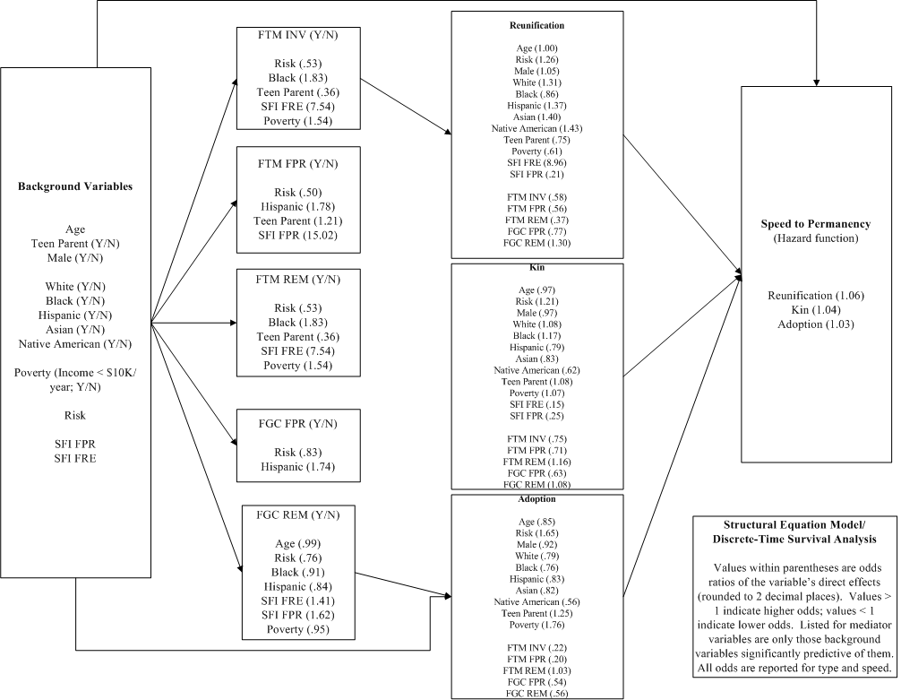

- Note: SFI FPR = Strengthening Families Initiative during Family Based Safety Services; SFI FRE = Strengthening Families Initiative during Family Reunification; FTM INV = Family Team Meeting during Investigation; FTM FPR = Family Team Meeting during Family Based Safety Services; FTM REM = Family Team Meeting after Removal; FGC FPR = Family Group Conference during Family Based Safety Services; FGC REM = Family Group Conference after Removal
- Note: In a structural equation model, odds ratios are computed by taking the natural logarithm of the parameter value

For visual simplicity, the structural equation model/discrete-time survival analysis (Figure 3) does not represent all the paths that were tested (nor does it represent the odds ratios for background and mediator variables--those are represented in the survival curves). Thus, speed (i.e., hazard) is regressed on the three types of permanent placement, the 5 mediators, and the 12 background variables (or a total of 20 paths); each of the 3 types of permanent placement is regressed on the 5 mediators and the 12 background variables (or 180 paths); and each of the 5 mediators is regressed on each of the 12 background variables (or 60 paths). The values represented in the structural equation/ discrete-time model are the odds ratios of the direct effects (i.e., no indirect effects were estimated).
The survival plot below shows survival curves for those with and without Family Team Meetings and Family Group Conferences in the investigation stage of service, Family Based Safety Services, and after Removal. Time increments (i.e., 1, 2, 3) on the x-axis are 3-month intervals. Family Group Conferences after Removal had almost exactly the same survival curve as the population, and in fact these two curves are visually indistinguishable from one another. Family Team Meetings (irrespective of stage) increased speed to permanent placement (relative to the population), with Family Team Meeting during the investigation stage of service having the greatest impact on speed to permanent placement.

Figure 4. Survival Curves for Family Team Meetings and Family Group Conferences

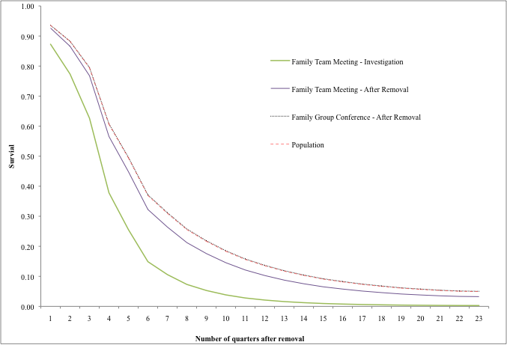
* Notes: Lines represent survival plots for Family Team Meeting during the investigation stage of service (FTMINV), Family Team Meeting after Removal (FTMREM), Family Group Conference after Removal (FGCREM), and the population survival analysis. The survival curves for the population and Family Group Conference after Removal are virtually the same, and visually indistinguishable. All Family Team Meeting curves fall below (faster) than the population.

Classification Tree Analysis
Because classification tree analysis is an exploratory technique, results are particularly sensitive to which variables (both predictor and outcome) are chosen. For example, Number of Placements had been used in a prior analysis (and it was the best predictor of type in that analysis), but after discussion with CPS staff, it was removed from the final analysis because it was determined to not be substantively meaningful. However, removing it also decreased predictive ability (i.e., percent correctly classified). These results are available in Appendix 15.
Interpretation starts at Node 0 (Reunification with family 44 percent, Placement with relatives 30.8 percent, Adoption 25.2 percent), with age at removal being the best predictor of differences in rates of reunification with family: reunification with family for the youngest children was 29.3 percent and for children over age 11 was 60.7 percent.

Table 7. Classification Table of the Classification Tree Analysis
Observed | Predicted
 | Reunification | Kin | Adopt | Percent Correct
Reunification | 20,861 | 1,426 | 1,809 | 86.6%
Kin | 12,835 | 1,917 | 2,111 | 11.4%
Adopt | 8,605 | 964 | 4,205 | 30.5%
Overall Percentage | 77.3% | 7.9% | 14.8% | 49.3%
Growing Method: Exhaustive CHAID
Dependent Variable: Type of permanent placement

Although the overall percentage correctly predicted by the model (49.3 percent) seems low, it is a significant improvement over chance. This improvement over chance prediction is represented in gains chart for reunification with family (Figure 5). The diagonal line represents chance prediction, and the area under the curve (i.e., between the curve and the diagonal line) represents improvement over chance prediction.

Figure 5. Gains Chart for Reunification with Family
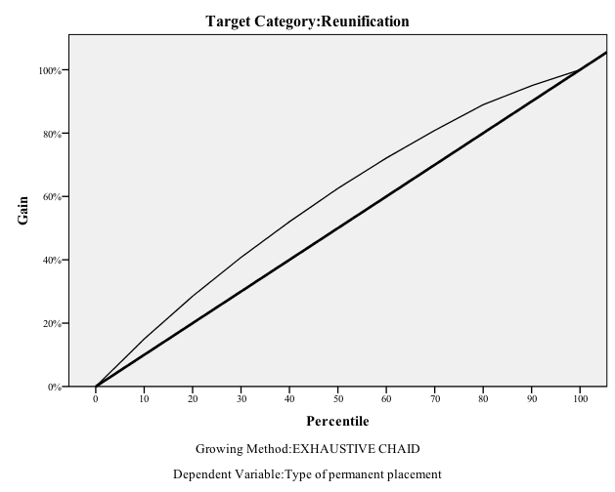

GLOSSARY

Age – The alleged victim’s age was calculated by date of birth. The analyses used the age of the eldest alleged victim in the household.
Classification Tree Analysis – Classification tree analysis is an analysis used to predict membership of cases or objects in the classes of a categorical dependent variable from one or more predictor variables. Classification tree analysis is one of the main techniques used in data mining.
Confirmed Investigation - A confirmed investigation is one with a disposition of Reason to Believe (RTB).
Destination – Where children go when they exit foster care (i.e., to their own homes, a relative’s home, adoption, emancipation, or other). Statistically valid subgroup analysis could only be performed on the first three exit destination types. There were insufficient numbers of children in the latter two destination types for a separate analysis.
Disposition – Assigned at the end of an investigation, dispositions include the following: reason-to-believe, ruled-out, unable to complete, unable-to-determine, and administrative closure.
Family Based Safety Services (FBSS) – Family-based safety services are protective services provided to a family whose children are not in the managing conservatorship of DFPS. There are three levels of family-based safety services--regular, moderate, and intensive. The level of service is determined by the degree of risk to the child.
Family Group Conferences – Family Group Conferences are a subcomponent of Family Group Decision-Making. These are meetings where families join with relatives, friends, the community, and CPS to develop a plan to ensure children are cared for and protected from future harm. Families join with relatives, friends, and community supports to develop a plan that ensures children are cared for and protected from future harm. Through the use of family time, the “family group” is vested with a high degree of decision-making authority and responsibility. During family time, the “family group” joins together to discuss and develop a plan for the child’s safety and well being.
Family Group Decision-Making – is a collaborative approach to service planning and decision making. The goal for families is to increase family participation in this collaborative approach with CPS in making decisions about their safety and service plans and to engage the extended family members, and other members of the family's support system, in this process. There are a variety of FGDM models used by DFPS, including Family Team Meetings, Family Group Conferences, and Circles of Support.

Family Team Meetings –Family Team Meetings are primarily held prior to the removal of a child. The purpose of Family Team Meetings is to use relatives, friends, and the community to ensure the safety of the youth and prevent removals. Family Team Meetings occur in a pre-removal situation in response to child safety concerns. FTMs are used to achieve positive outcomes for children in the earliest stages of CPS involvement and family connections by engaging family, community members, and other caregivers in critical decisions related to protecting children, safety, placement, and permanence.
Foster Care – A subset of the substitute care system, foster care refers to placements via Child Placement Agencies, in foster family homes, in Residential Treatment Centers, or Emergency Shelters. Kinship Care placements or Foster Home placements which are pending adoption, are excluded from this categorization.
Household Income – The annual household income of the alleged victim’s family was recorded on the DFPS file in one of the following categories: less than $10,150; $10,150 – $20,549; $20,550 – $40,549; $40,550 – $62,999; and $63,000 or more. Because the highest categories had similar effects in the analysis, the research team collapsed them into one category, $40,550 or more.
Investigation Stage – The investigation stage includes stage types identical to those in intake, a combination of the primary allegation, plus the priority. The stage type in investigation is determined in intake and is static throughout the investigation stage.
Latent Class Analysis – Latent class analysis is a subset of structural equation modeling, and is used to find groups or subtypes of cases in multivariate data. These subtypes are called “latent classes.”
Odds Ratio – Compares the odds of an event occurring versus not occurring for two groups. The resulting odds ratio tells us how much more or less likely it is for one group to have an event (i.e., the removal of an African American child) compared to another group (i.e., the removal of an Anglo child). EX: (# of African American children removed in 2008 / # of African American children investigated but not removed in 2008) / (# of Anglo children removed in 2008 / # of Anglo children investigated but not removed in 2008).
Parents’ Marital Status – Each record in a case on the investigation file identified the person’s marital status and his/her relationship to the alleged victim, such as parent or stepparent. To calculate marital status, the researchers counted the number of married parents/stepparents in an investigated case. If two or more married parents were found for the case, the family was coded as married.
Race/ethnicity – Race/ethnicity categories for a family in an investigated case were recorded on the DFPS files. When family data were used, the race/ethnicity of the oldest victim was used. The categories include African American, Hispanic, Anglo, Asian, Native American, and Other/Unknown.
Recurrence - To study recurrence of investigations of abuse and neglect, cases were matched and then categorized as (a) a single investigation (i.e., no recurrence), (b) multiple completed investigations without any confirmed, (c) multiple completed investigations with only 1 confirmed, and (d) multiple completed investigations with 2 or more confirmed. Recurrence was defined as either multiple investigations or multiple confirmed investigations.
Region of State – Region is based on a family’s county of residence in the investigation file at the close of investigation.
Relative/Kinship Placement – Kinship care is the umbrella term used to describe substitute care that is provided to a child in DFPS conservatorship by relatives or fictive kin who live outside of the child’s home.
Removal Stage – A child can be removed from the home at the investigation stage or a child can be removed from home after the investigation stage has been closed and the family's case has been opened for Family Based Safety services.
Reunification – The primary permanency goal for most youth in foster care, reunification occurs when the biological family meets its safety criteria and the child(ren) are able to return.
Risk Score – The seven risk scores from the Texas Concept Guided Risk & Safety Assessment were summed into a total score.
Strengthening Families Initiative - Strengthening Families Initiative stands for the pilot program, "Strengthening Families Through Enhanced In-Home Support." The support was intended to alleviate immediate poverty-related issues that contributed to child neglect and came in the form of intensive FBSS services coupled with financial components to provide non-traditional services to qualifying families ($3,250 per family maximum).
Structural Equation Modeling – A statistical technique for constructing and simultaneously testing causal pathways between concepts.
Substantiated – A case is considered substantiated if the caseworker finds reason to believe the allegations are true.
Substitute Care System – This is referred to as foster care in most states and substitute care in Texas. Substitute care services in Texas include an array of services provided to children once they are determined to be the legal responsibility of DFPS and are removed from the home. These include foster care, kinship care, therapeutic foster care, emergency shelters, residential group care, post-placement supervision, adoption, independent living skills, and recruitment and training activities for foster and adoptive parents.
Survival Analysis – A method for estimating the time to a given event while taking into account events that have not yet happened.
Teen Parent – Teen parent status was calculated using the parent or stepparent’s date of birth. Parents were considered teens if they were age 19 years or younger.
Type of Allegation of Abuse or Neglect – Allegations (reports of child abuse and/or neglect received by Statewide Intake) were categorized into mutually exclusive groups: multiple maltreatment, abandonment, physical abuse, neglect, sexual abuse, and emotional abuse.

Though adoptions are sometimes facilitated through family group decision-making (e.g., relative adoptions), the data to analyze this phenomenon were not available.
The data for these evaluations spanned dates between 2003 and 2009. The use of the Family Group Decision Making model was expanded in Family Based Safety services and in the Investigation Stage of service statewide in early FY 2008.
The data for these evaluations spanned dates between 2003 and 2009. The use of the Family Group Decision Making model was expanded in Family Based Safety services and in the Investigation Stage of service statewide in early FY 2008. In addition, Family Team Meetings are fairly rare post-removal.

