Substance Abuse Services/Substance Use Disorder Services Client Satisfaction Survey Questionnaire
Child Protective Services - Purchased Client Services
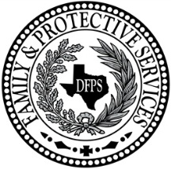
Date: ____________ Facilitator: _____________________________
Agency: _____________________________

Put an X in the box for your answer to each question. If the question does not apply to you, mark NA for Not Applicable. | Strongly Agree | Agree | Disagree | Strongly Disagree | NA
1. My therapist believes that I can change and grow and manage my addiction.
2. My therapist encourages me to be responsible for the safety of my kids and make plans for their care if I relapse.
3. My therapist makes me feel comfortable talking about my addiction and how it affects my life and my family.
4. I understand the problems that caused CPS to open a case and I am trying to take better care of my kid(s).
5. My therapist encourages me to attend other classes or join other support groups or participate in community activities. I found other agencies or groups that could help me with my addiction and with other areas of my life.
6. If I had other choices, I would still get services from this therapist.
7. This therapy made positive changes in my life and in how I parent my kids and I would tell someone to try this kind of therapy if they had problems with addiction.

Comments (What did you like most about therapy? Like least? Is there anything you wanted that was not part of the therapy?)

Thank you. We value your feedback

